**Question 1**

1a)

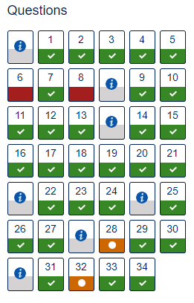

1b)

Parts of this quiz were challenging and took more than one attempt. Question 6 was attempted when very tired and due to this kept misreading the question. I struggled to get my head round question 8 and found the relevant module material did not explain it properly. This question was discussed in an online forum with differing answers. The quiz questions based on parts 6 and 7 took some time figuring out with repeated reading of the module material. The python quiz questions were the most enjoyable.

(87 words)

**Question 2**

2a)

Your report has a poor structure which effects the clarity of the information. The terms ‘Cloud Computing’, ‘Internet of Things’ and ‘CloudIoT’ required clearer explanation for the intended audience. The examples given to illustrate your argument are sufficient however only three are asked for which they could have been expanded upon. There is a lack of good academic practice with no in-text citation or referencing of the article. The link on your Bibliography seems broken. A visible word count would have helped identify that more words were available to give greater depth to your report. It would be beneficial to spend some time learning the general structure of a report; the OU Study Skills website is a good place to start. Learning to begin with an introduction, with each new idea in a new paragraph along with a conclusion would help the information you have portrayed to be easily digested.

2b) i)

Smart vehicles will consume huge computer processing power for data processing which is essential to avoid collisions, route planning and communicating with vehicles. This processing power needs to be available at faster speeds than centralized data centres currently offer due to latency issues caused by long distances of data travel.

(50 words)

2b) ii)

There is a common consensus between technology companies for an ‘edge computing network’ that would benefit devices like smart cars. This network is made up of a large number of smaller localised outposts or micro-centres which contain a few servers. These decentralized centres would distribute the computer processing power up to 10 times faster than the centralized data centres.

US Telecom companies are adopting the faster data speeds of the 5G network to build edge computing networks. They can use the already huge country wide constructed network of cell, fibre optic cables and related buildings for this network. Therefore, the data may only need to travel a few miles rather than long distances to data centres dramatically improving latency. Another way of increasing latency speeds is to push some of the cloud processing back on to customers hardware devices which can help juggle the processing (Hsu, 2017).

(147 words)

**Question 3**

3a)

The input is a list of toy sales with admissible values being from zero to a positive integer.

The output is the range between the highest and lowest quantity of sales from the list.

3b)

Tests:

|  |  |  |
| --- | --- | --- |
| Input | Output |  |
| *daily_sales* | *range* | *Comment* |
| [1, 10, 9, 0] | 10 | Maximum range: at least one day’s sales is zero |
| [5, 5, 5, 5] | 0 | Minimum range: all sales are the same |

3c)

> Compute the range of toy sales

>> Determine the lowest of the sales (retrieval: find best)

>> Determine the highest of the sales (retrieval: find best)

>> Compute the range of the highest and lowest sales (formula)

3d)

File: TM112_TMA02_Q3_WS2343.py

# Compute the range of toy sales

# Input: a list of toy sales, positive integers

toy_sales = [7, 6, 0, 10] # Maximum possible range

# Sub-problem: find the lowest and highest sales

lowest = toy_sales[0]

highest = toy_sales[0]

for sales in range(1, len(toy_sales)):

if toy_sales[sales] < lowest:

lowest = toy_sales[sales]

elif toy_sales[sales] > highest:

highest = toy_sales[sales]

# Sub-problem: compute the range of highest and lowest sales

range = highest - lowest

# Output: range, integer, maybe zero

print("The range of the toy sales is",highest, "-", lowest, "=", range)

**Question 4**

4a)

|  |  |
| --- | --- |
| Sensor | Point in the scenario |
| Radio receiver | When Ahmed’s phone started to vibrate. Radio waves were being received. |
| Touch screen | Swiping answer call button on the touch screen. |
| Microphone | When Ahmed was having a conversation with his girlfriend. |
| Touch screen | Jabbed the end call icon on the touch screen. |
| Radio receiver | Downloading of video through internet using wi-fi. |
| Headphone jack | Plugged in headphone. |
| Accelerometer and Gyroscopes | Rotation of phone so video could be watched in portrait mode. |

4b) i)

|  |  |  |
| --- | --- | --- |
| **Activity** **number** | **Activity** | **Estimated time in minutes (rounded to the nearest tenth of a minute)** |
| 1 | Interacting synchronously with one or more other people using voice (i.e. phone calls) or voice and video | 12.7 |
| 2 | Interacting asynchronously with one or more other people using text (i.e. messaging) | 3.4 |
| 3 | Accessing other people’s work for entertainment (watching video, listening to music, reading a book) | 39 |
| 4 | Playing games | 18 |
| 5 | Location-based services to find a location or access your position on a preloaded map | 0 |
| 6 | Writing or reading emails | 5.5 |
| 7 | Using the web, either from a browser, or an app to look up information or purchase goods (news services, weather, online shopping, timetables, search engines) | 32 |
| 8 | Checking for messages/calls/alerts/signal/battery life/time | 6.6 |
| 9 | Taking photographs, or looking at photographs stored on your phone | 0 |
| 10 | Uploading data from your phone to another device or location, or downloading data to your phone from another device or location | 0 |
| 11 | Recording or retrieving your own information (making or reading notes/diary entries, editing contacts, editing documents, etc.) | 0 |
| 12 | Social media (Twitter, Facebook, etc.) | 41 |
| 13 | Other (anything that does not fit into one of the above categories) | 0 |
|  | Total | 158.2 |

4b) ii)

Social Media at 41 minutes was the category that I spent the most time on. Therefore,

percentage of time = minutes on social media $×$ 100 . total minutes on phone

= 41 $×$ 100 . 158.2

= 25.9% (to 1 decimal place).

4b) iii)

The data collected was a representation of mobile phone usage on a working day. This, for me was interesting to discover any differences from a non-working day. Approximately a quarter of my usage was on social media. This was unsurprising since starting the Open University degree the use of Facebook and WhatsApp has increased significantly due to communicating with fellow students. The other time-consuming activities of listening to music and using the web are as expected; once you get engrossed into something then time does seem to pass quickly. Several issues arose when collecting and recording the information which was written on a notepad. Trying to collect times to a tenth of a second was problematic for most activities therefore I decided to round to the nearest minute. Being aware what I was doing and switching between activities quickly may have influenced what and how long an activity lasted. Due to the issues mentioned the accuracy will have been affected in terms of times of each activity, but in percentage terms it will be more accurate. This is because I would always be performing certain activities more than others. If this investigation was performed again I would look into using third party application(s) that can track activity usage more accurately.

4b) iv)

My point of discussion:

<https://learn2.open.ac.uk/mod/forumng/discuss.php?d=2633924#p19017820>



I replied on posting:

<https://learn2.open.ac.uk/mod/forumng/discuss.php?d=2633924#p19043512>

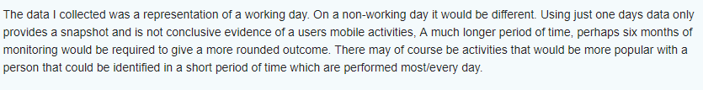

**Question 5**

5a)

strings_list = [‘a’, ‘b’]

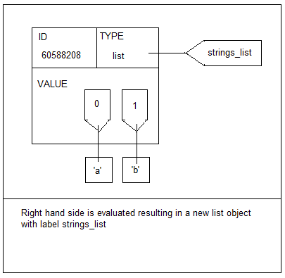

Strings_list[0] = ‘e’

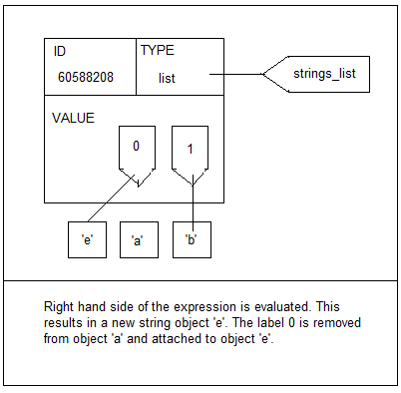

5b) i)

Decomposition

> Compute number of lorries required to concrete floor

>> Compute size of floor

>> Compute volume of concrete lorry can hold

>> Compute number of lorries required

>>> Round up number of lorries required

5b) ii)

Algorithm

1 > Compute number of lorries required to concrete floor

2 initialise *floor_width, floor_length* and *floor_height*

3 initialise *lorry_radius* and *lorry_length*

4 >> Compute size of floor

5 set *floor_size* to *floor_width* * *floor_length* * *floor_height*

6 >> Compute volume of concrete lorry can hold

7 set *lorry_volume* to *lorry_radius* * *lorry_radius* * 3.14159 * *lorry_length*

8 >> Compute number of lorries required

9 set *number_lorries* to *floor_size* / *lorry_volume*

10 >>> Round up number of lorries required

11 if *number_lorries* is not equal to a whole number:

11a set *lorries_required* to next rounded up number

12 print *lorries_required*

5b) iii)

File: TM112_18D_TMA02_Q5_WS2343.py

# TM112 18D TMA02 WS2343 Question 5

""" Computes number of lorries required to concrete

a floor of given dimensions ”””

def calculate_number_lorries(width, length, height, radius,l_length):

"""Compute number of lorries required by dividng floor size

by lorry volume"""

floor_size = width * length * height

lorry_volume = radius * radius * 3.14159 * l_length

number_lorries = floor_size / lorry_volume

lorries_required = float_rounded_up(number_lorries)

return lorries_required

# Input: Floor dimensions, positive number

floor_width = 5

floor_length = 4

floor_height = 2

# Input: Lorry dimensions, positive number

lorry_radius = 1.5

lorry_length = 3

# Sub-problem: Compute number of lorries required

lorries = calculate_number_lorries(floor_width, floor_length, floor_height,

lorry_radius, lorry_length)

# Output: Lorries required, an integer

print("The number of lorries required is", lorries)

**Question 6**

6a) i)

The following Python code was added to the file q6a.py.

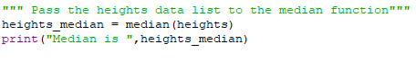

When this file was run, produced the output:



Therefore, the median of the highest pointsis 2260 metres.

6a) ii)

A possible reason why the mean of 2185 metres is lower than the median of 2260 metres is that the distribution of data is more to the lower point values especially 0-499. The higher point values are sparse in comparison. These values are pulling down the mean.

6b) i)

The following code was added to the file q6b.py.



When this is run, produced the output:



Therefore, the correlation coefficient is $-$ 0.91 (to 2 decimal places).

6b) ii)

The level of correlation is very high.

6b) iii)

The very high effect of correlation where newspaper sales are decreasing and cars increasing on roads could suggest people are becoming more outgoing rather than sitting still and reading. However, additional factors like online newspapers and increasing population could be the driving force behind these figures. Therefore, this is not likely to be casual.

(54 words)

**Question 7**

7a)

Using the Global Positioning System (GPS) location-based system would be the most appropriate approach to track competitors across Dartmoor.

7b)

This approach uses three or four satellites for greater accuracy that send out radio frequency signals which are picked up by a GPS receiver on the ground. The receiver measures the propagation time and the velocity of each signal to determine the distance or trilateration from each satellite. Each distance forms a circle around the satellite, where these circles intersect is the precise point of the GPS receiver therefore giving a latitude and longitude location (Hirst, 2018) and in *looking up latitude/longitude coordinates animation*.

7c)

The GPS location approach would not work in an indoor shopping centre because it requires an unobstructed view of the satellites which in this instance the line of sight would be obstructed by physical objects. An alternative approach would be to use Bluetooth beacons. These could be installed in the taster event in the indoor shopping centre giving contextual alerts to passes by telling them the location of the event (Hirst, 2018).

**Question 8**

8a) i)

The name given to soliciting information from particular individuals is spear phishing.

8a) ii)

An advanced persistent threat (APT) is the term given where an attacker uses a series of attacks to gain access to a system and remains undetected for a long time.

8a) iii)

Two of the three CIA principles were threatened by the attack. Highly confidential data was stolen from the Democratic National Committee (DNC) internal network which is an attack on confidentially. With this data being stolen and past on to media outlets, unauthorised people had access to the data which could be altered and manipulated which is an attack on integrity. The availability of the data to the DNC was not stopped or restricted because the attack was centred on harvesting data rather than denying access.

8b)

Protecting your email account(s) using multi-level security will minimise the risk of viruses or unauthorised access. For each email account a unique password should be created, and needs be different from any other password you use online. Therefore, if an account was hacked, the hacker would not be able to access other accounts easily. ConnectSafely (2018) recommends upper and lower case random words mixed with letters and symbols of a minimum length of twelve characters. It should be something that can be remembered but difficult to replicate. Avoid using passwords that contain personal information and numbers that go in sequence.

A second level of security is to install a virus program that can scan emails and attachments for potentially harmful malware. Clicking on unexpected links could lead to downloading of malware or viruses. An installed virus checker may be able to catch and isolate these potentially dangerous programs, but it is not advisable to click on links or attachments that you are not expecting. The virus checker needs to be kept up to date to be working effectively.

Be aware of emails that can imitate high profile websites such as amazon or online banking that may require you to enter or update personal information. They often ask you to click on a link that takes you to a webpage that imitates the official webpage. These fake emails known as phishing emails can appear when you may have been on the equivalent official websites. Never give personal information without being certain that it is from a reliable source. If in doubt go to the official website by typing in the web sites Uniform Resource Locator (URL) or contact by another method (Lee, 2012).

(282 words)

**References**

Connect Safely (2018) *Tips for strong, secure passwords & other authentication tools* [Online]. Available at <http://www.connectsafely.org/tips-to-create-and-manage-strong-passwords/> (Accessed 9 June 2018).

Hirst, T. (2018) *TM112 Part 6: Location-based computing,* Milton Keynes, The Open University.

Hsu, J. (2017) *It’s time to think beyond cloud computing* [online]. Available at https://www.wired.com/story/its-time-to-think-beyond-cloud-computing/ (Accessed 10th May 2018).

Lee, J. (2018) *7 important email security tips you should know about* [Online]. Available at <https://www.makeuseof.com/tag/7-important-email-security-tips-you-should-know-about/> (Accessed 9 June 2018).

The open University (2018) ‘Looking up latitude/longitude coordinates animation’ [Video], *TM112 Introduction to computing and information technology 2.* Available at <https://learn2.open.ac.uk/mod/oucontent/view.php?id=1305968> (Accessed 6 June 2018).